**Business Question and Visualization Report**

Date

28

june2025

Team ID

LTVIP2025TMID50924

Project Name

Visualizing Housing Market Trends: An

Analysis of Sale Prices and Features using

Tableau

Maximum Marks

5

Marks

1. **What is the average sale price of houses?**

**Visualization:** Summary dashboard showing the average sale price of houses.

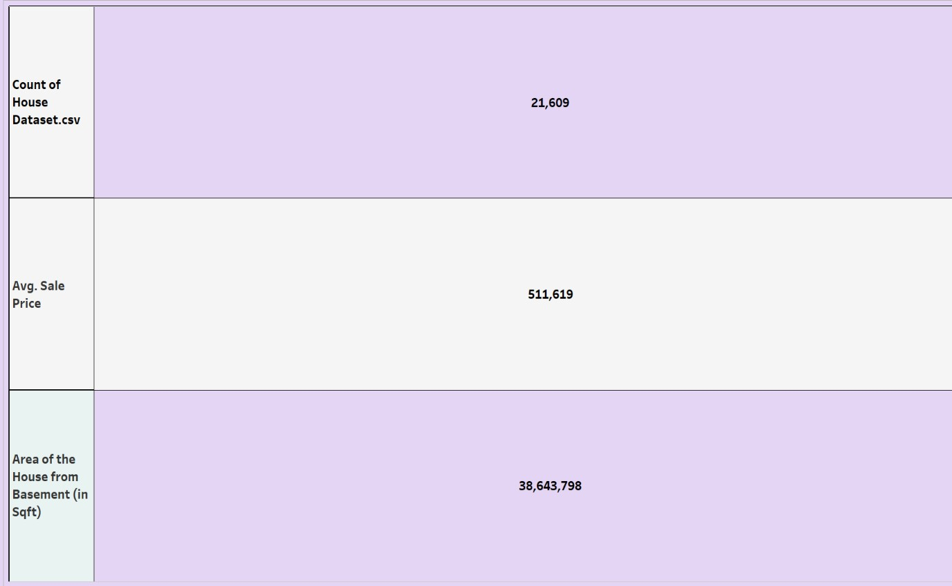

1. **Which basement size shows the highest sale price?**

**Visualization:** Bar chart showing the highest sale price.

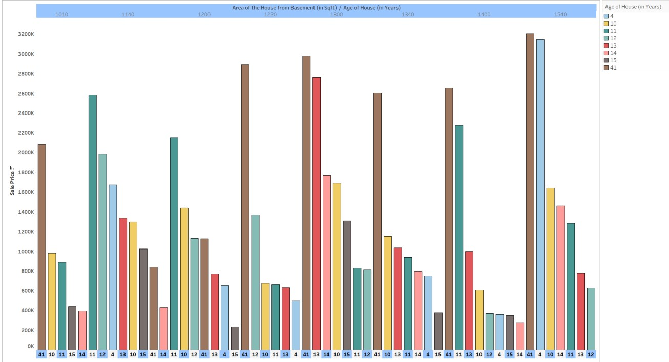

1. **Which price range has the lowest number of sales?**

**Visualization:** Bar chart showing the lowest number of sales.

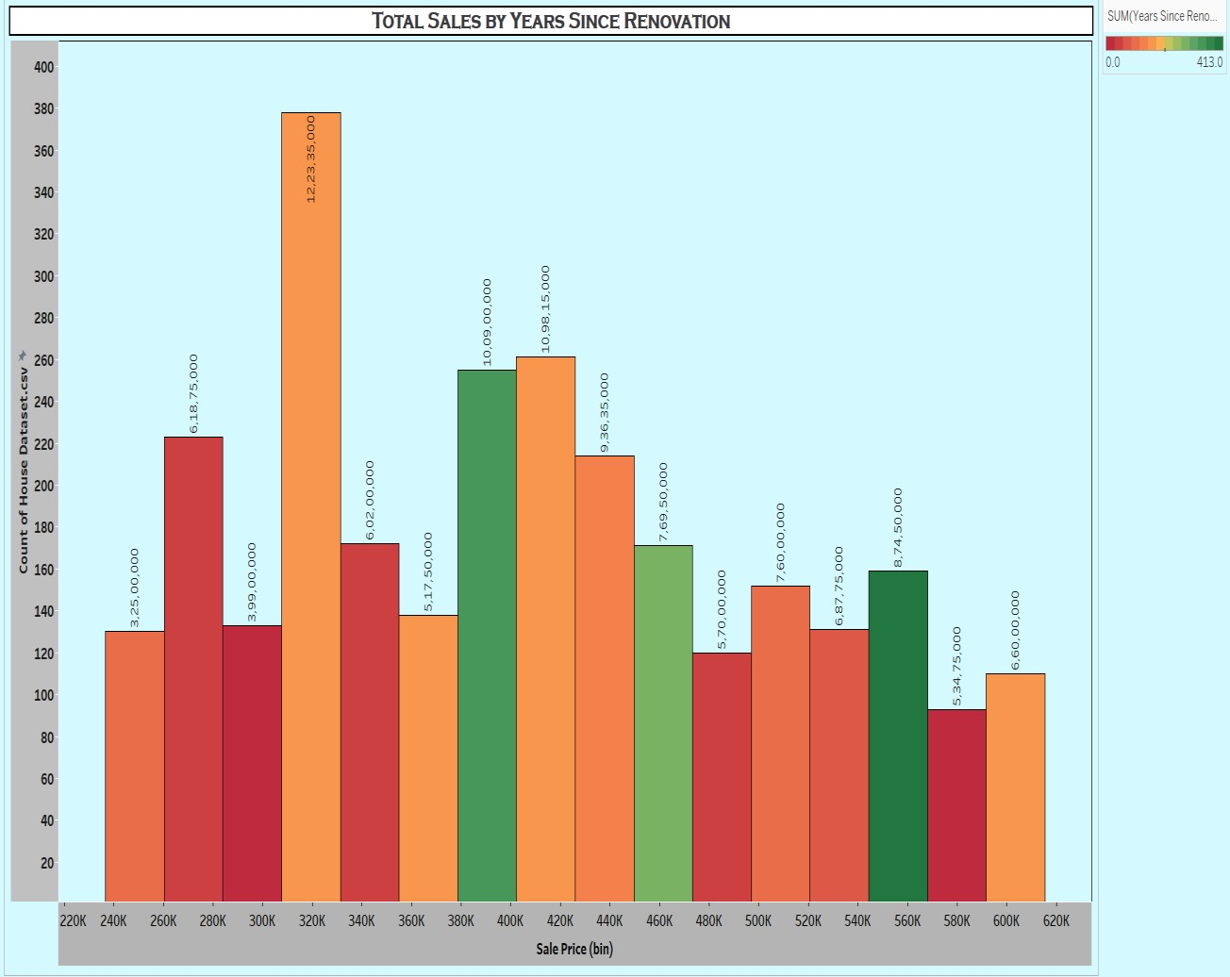

1. **What does the color coding represent?**

**Visualization:** Line chart represents different house ages.

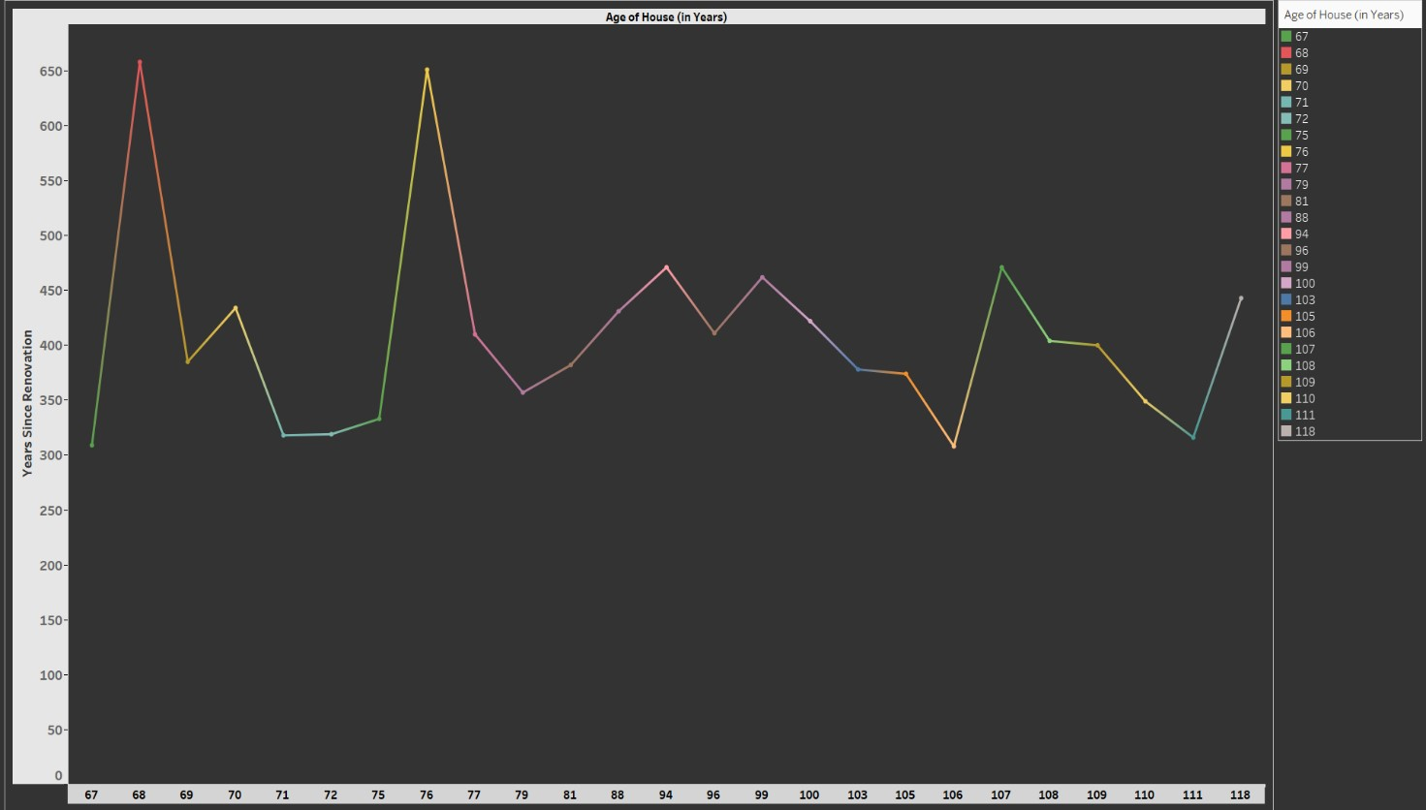

1. **How many different houses age categories are shown?**

**Visualization:** Pie chart showing the different houses age categories.

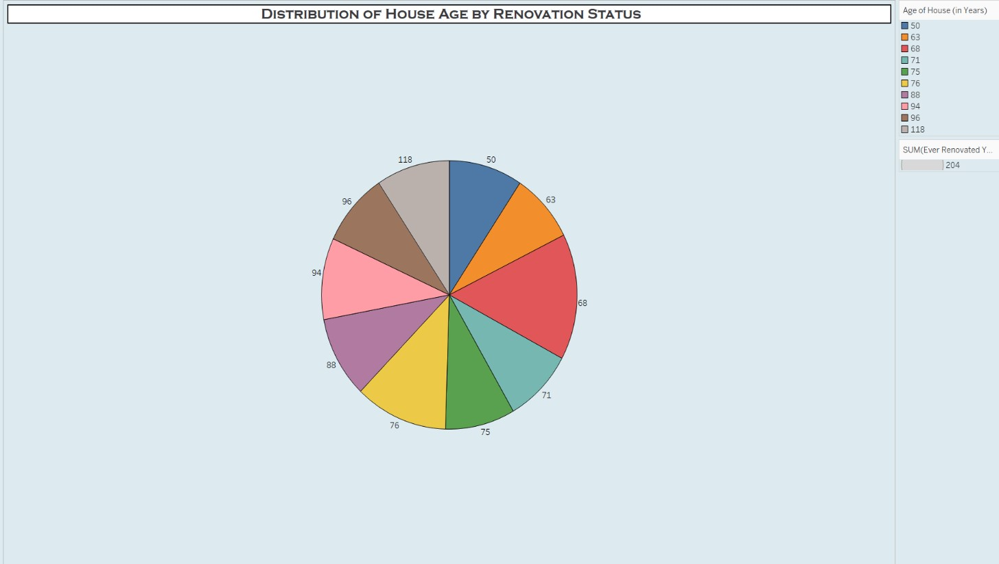

1. **What age groups of houses are included in the chart?**

**Visualization:** Bar chart shows the age group of houses.

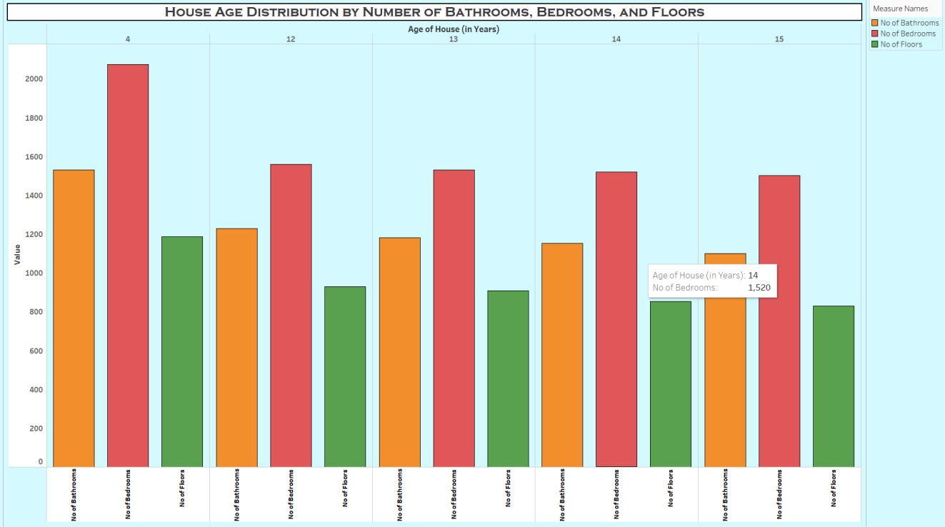

1. **What is the count of houses in the dataset for each house age?**

**Visualization:** Text table show the count of houses in the dataset for each house age.

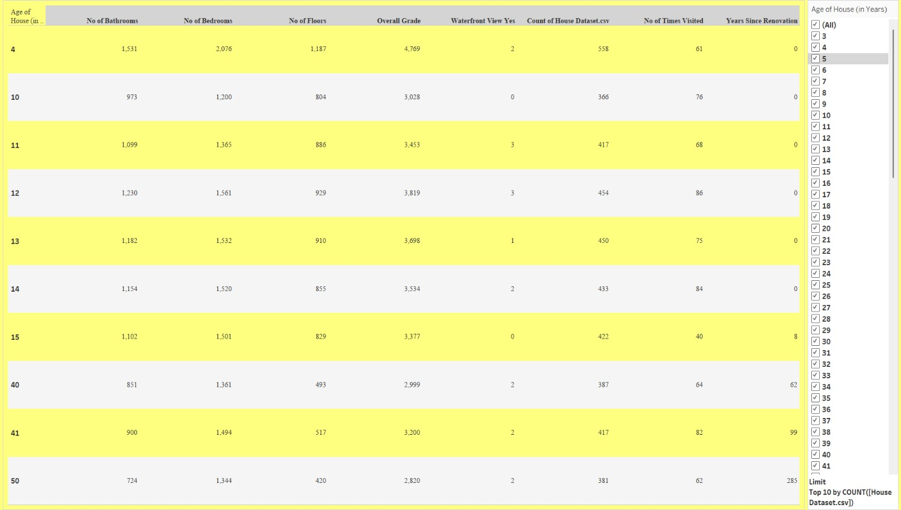

1. **Which price bins have the least number of houses?**

**Visualization:** Horizontal bar chart shows the least number of houses.

